Library for Environmental Practices and Circular Economy

Introduction
Circular economy and environmental sustainability lay at the forefront of our design and facilitation practices in Fundacja Fantazmat. We create our LARPs as low-cost, low-entry, community-building and educational tools, in which both matters not only play a crucial role, but also directly tie in with the economical principles we follow. The games we create often capitalize on the potential of digital tools to create and distribute informational materials as well as game elements, use unique properties of existing locations to support storytelling, re-use, recycle and upcycle costumes, props and scenography elements, as well as share them with potential participants in order to both lower the entry threshold into the hobby as well as minimize waste of resources.
We tend to make our games flexible player-wise as well as viable in the case of circular economy principles with the combination of reusable props and suggestions on how to set up the games in various locations, using the list of predetermined props and scenography elements, many of which tend to be everyday items adapted or re-purposed in accordance with the need of specific scenarios. A similar principle is used in terms of costumes and player preparation, with use providing reusable elements of these and suggesting how to turn mundane items into elements of said costumes. In case of all the aforementioned elements we are simultaneously being always on the lookout for new and interesting pieces which could be up-cycled and given new life in the context of our work, cooperating with local cultural institutions such as theatres, accepting donations from our community as well as scouring yard sales, second-hand stores and flea markets.
While designing each game we do not only focus on pre-design research when it comes to its contents (which in many cases includes themes of environmental activism) but also pay attention to costumes, space and scenography design, props and needed physical elements and other physical factors. In the first place, we focus on using an existing base of physical elements or their potential repurposing for tor specific games. After that we use our network to look for the missing elements with the emphasis on upcycling potentially unused or obsolete materials. Only after that, do we turn towards buying new elements.
Throughout a decade of operating both as an informal group and later an organization, we came up with ways and ideas on how to adapt existing spaces to the needs of our games with the use of a set of predetermined items and strategies, the latter of which are sourced either from our own practice or from the experience of other creators. Thus, we acquired said elements and reuse them constantly in different configurations, extending the life of many items in our storage.
These methodologies not only allow us to stay environmentally-friendly and put circular economy principles in practice, but also perfectly reinforce our goal of the games being available for a wider audience thanks to low entry costs as well as a community-oriented and driven model of operations.

Environmental Game Design Methodology
LARPs
We specialize in LARP design and facilitation, treating it as a multisensory immersive experience allowing for active learning through the principles of pedagogy of experience, experiential learning cycle and situated learning.
Our games are not only designed as community-building tools but also as educational experiences which allow for the development of soft skills, as well as foster the raise of awareness about social and environmental issues. We combine emergent and environmental storytelling, roles and character embodiment with meaningful play and causality tied to consequences for the players to provide a meaningful learning environment.
Environmental themes are either present as parts of the main narrative or on a meta level in the approach we promote towards both design and facilitation of LARPs.
Integrating Environmental Awareness into Gameplay and Mechanics
LARP as a medium allows design in a way that encourages decision-making white simultaneously bearing no real-life consequences and being able to provide almost instant feedback on taken choices and their consequences. Thus, scenarios where the players are tasked with preparing for or averting a crisis as well as those which force them to function post-disaster work best, especially with pupils in school setting, as they provide causality. Mechanics like resource management, negotiation and information research/collection are ones which tend to be the most useful design-wise.
Environmental themes and messaging in games
Environmental themes are integrated into the game through the overall story and quests as well. This is done on both general level, through briefings, materials openly available for players and props as well as on a more personalized level through character sheets and there via backstories, motivations and goals of the characters. This scattered information is, partially, what drives the story onwards as the players are usually forced to cooperate on solving specific environment-related issues such as, for instance, preparing a city for the rapidly progressing climate change. Every game is preceded by the educational debrief which sums up the debrief in which relevant matters are discussed, the more thoroughly if the purpose of the game is purely educational.
Impact and Educational Effectiveness of Games
We usually settle on post tests or short surveys, quizzes and suggestion boxes when analyzing the educational impact of our game, as well as promoting and facilitating discussions. We also collect anonymous player feedback while also consulting with teachers and educators working with the groups we visit on a daily basis. It is with the youth working with and around our NGO that we observe more long-term changes in shift towards more sustainable behaviors and solutions than to more frequent interaction with them.
Collaborations and Community Engagement
Rather than partnering with environmental organisations, we usually partner with the educational sector, using the ever-expanding network of local schools we had developed throughout the years. However, building a wider outreach is something we intend to do in the process of our NGOs development. Yet we encourage the youth to actively implement the knowledge gained through the experience of playing our games in order to take up climate-friendly actions, while also using social media to promote our efforts and agenda.
Conclusions and Recommendations
Our approach to LARP design and facilitation emphasizes the environment-friendly approach not only through themes we explore in our games but also through the ways we design and facilitate them as well as practices we build and model within the community used on a daily basis. These elements combined foster the sense of environmental responsibility and raise awareness in regard to the environment and current challenges in that regard.
To provide transformative impacts LARPs must be both engaging and safe while providing actionability and the feeling of high stakes being at play against the limited time or a looming threat. Information should be distributed evenly in small, digestible amounts, necessitating player interaction and learning by exchanging them. The level of props, costumes and sonography is dependent on budget and other constraints like target group and time imitations for gameplay. Sustainable practices can be shown and implemented even before the game if possible, for instance by distributing information digitally.
Environmentally Conscious Games Examples

Climate Perspectives
Webpage/source: | https://nausika.eu/climate-perspectives/
Company or organization that has developed the game | Nausika Foundation
Type of game | Educational LARP (edu-LARP)
Description | Diplomats from countries all around the globe gather on a climate peak in the year 2050. Local interests of particular countries clash with the global goal of protecting the planet. The game is asking questions about the world of international politics and how it shapes our environment.
Environmental Features Checklist | Education on Sustainable Development Goals  Promotion of collaboration for sustainability  Emphasis on practical solutions to reduce emissions
Images (1/good practice) | 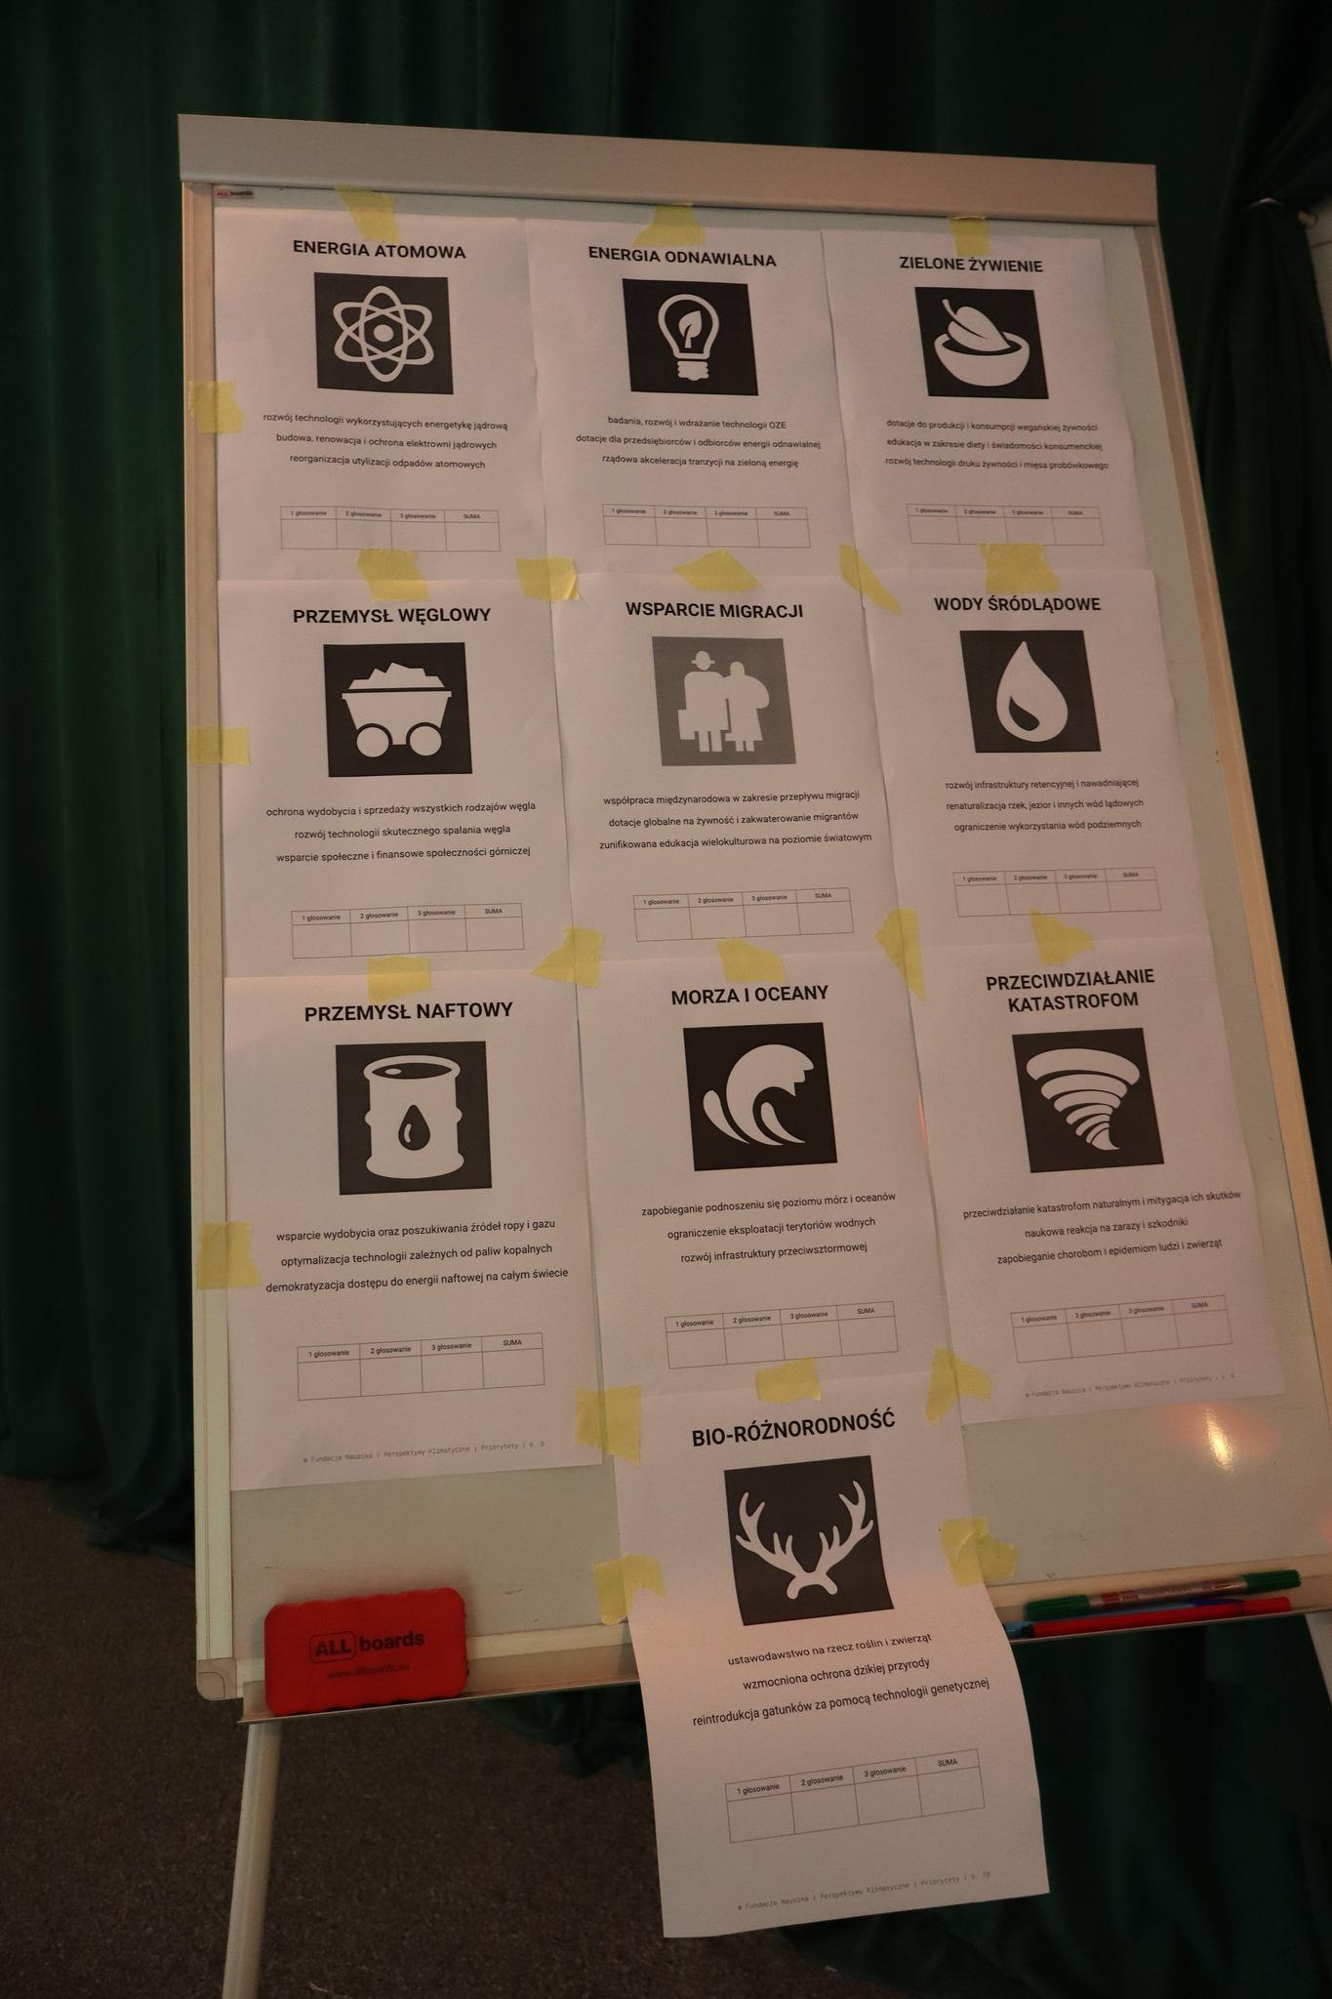

A Tree Of Life
Webpage/source: | https://ctc.ee/publications/games/a-tree-of-life
Company or organization that has developed the game | Peipsi Center for Transboundary Cooperation
Type of game | Educational LARP (edu-LARP)
Description | The creatures who live in different parts of a giant tree need to find solutions to mysterious problems affecting their home and well-being. A game for young players, touching the topics of community, responsibility and problem-solving, wrapped up in a multi-layer metaphor of the Tree of Life.
Environmental Features Checklist | Raising awareness about the inner workings of ecosystems.
Images (1/good practice) | 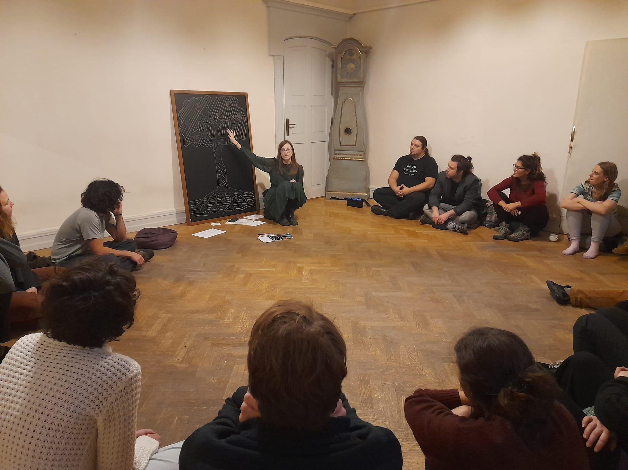

City That Breaths
Webpage/source: | https://www.facebook.com/profile/100063212051323/search/?q=Miasto%20kt%C3%B3re%20oddycha
Company or organization that has developed the game | Fundacja Fantazmat
Type of game | Educational LARP (edu-LARP)
Description | An edu-LARP where players are cast as members of various interest groups comprising the city population, which often have conflicting interests and goals. During the emergency meeting organized by The City Council they must resolve several crises related to the lack of green and blue infrastructure in the city, to prepare it for the incoming climate change.  (English version of the game still in development)
Environmental Features Checklist | Education on blue and green solutions in the sustainability of cities.  Promotion of sustainable practices on micro (personal) and macro (city-wide) level  Building awareness of solutions and practices able to reinforce green transformation in cities among students
Images (1/good practice) | 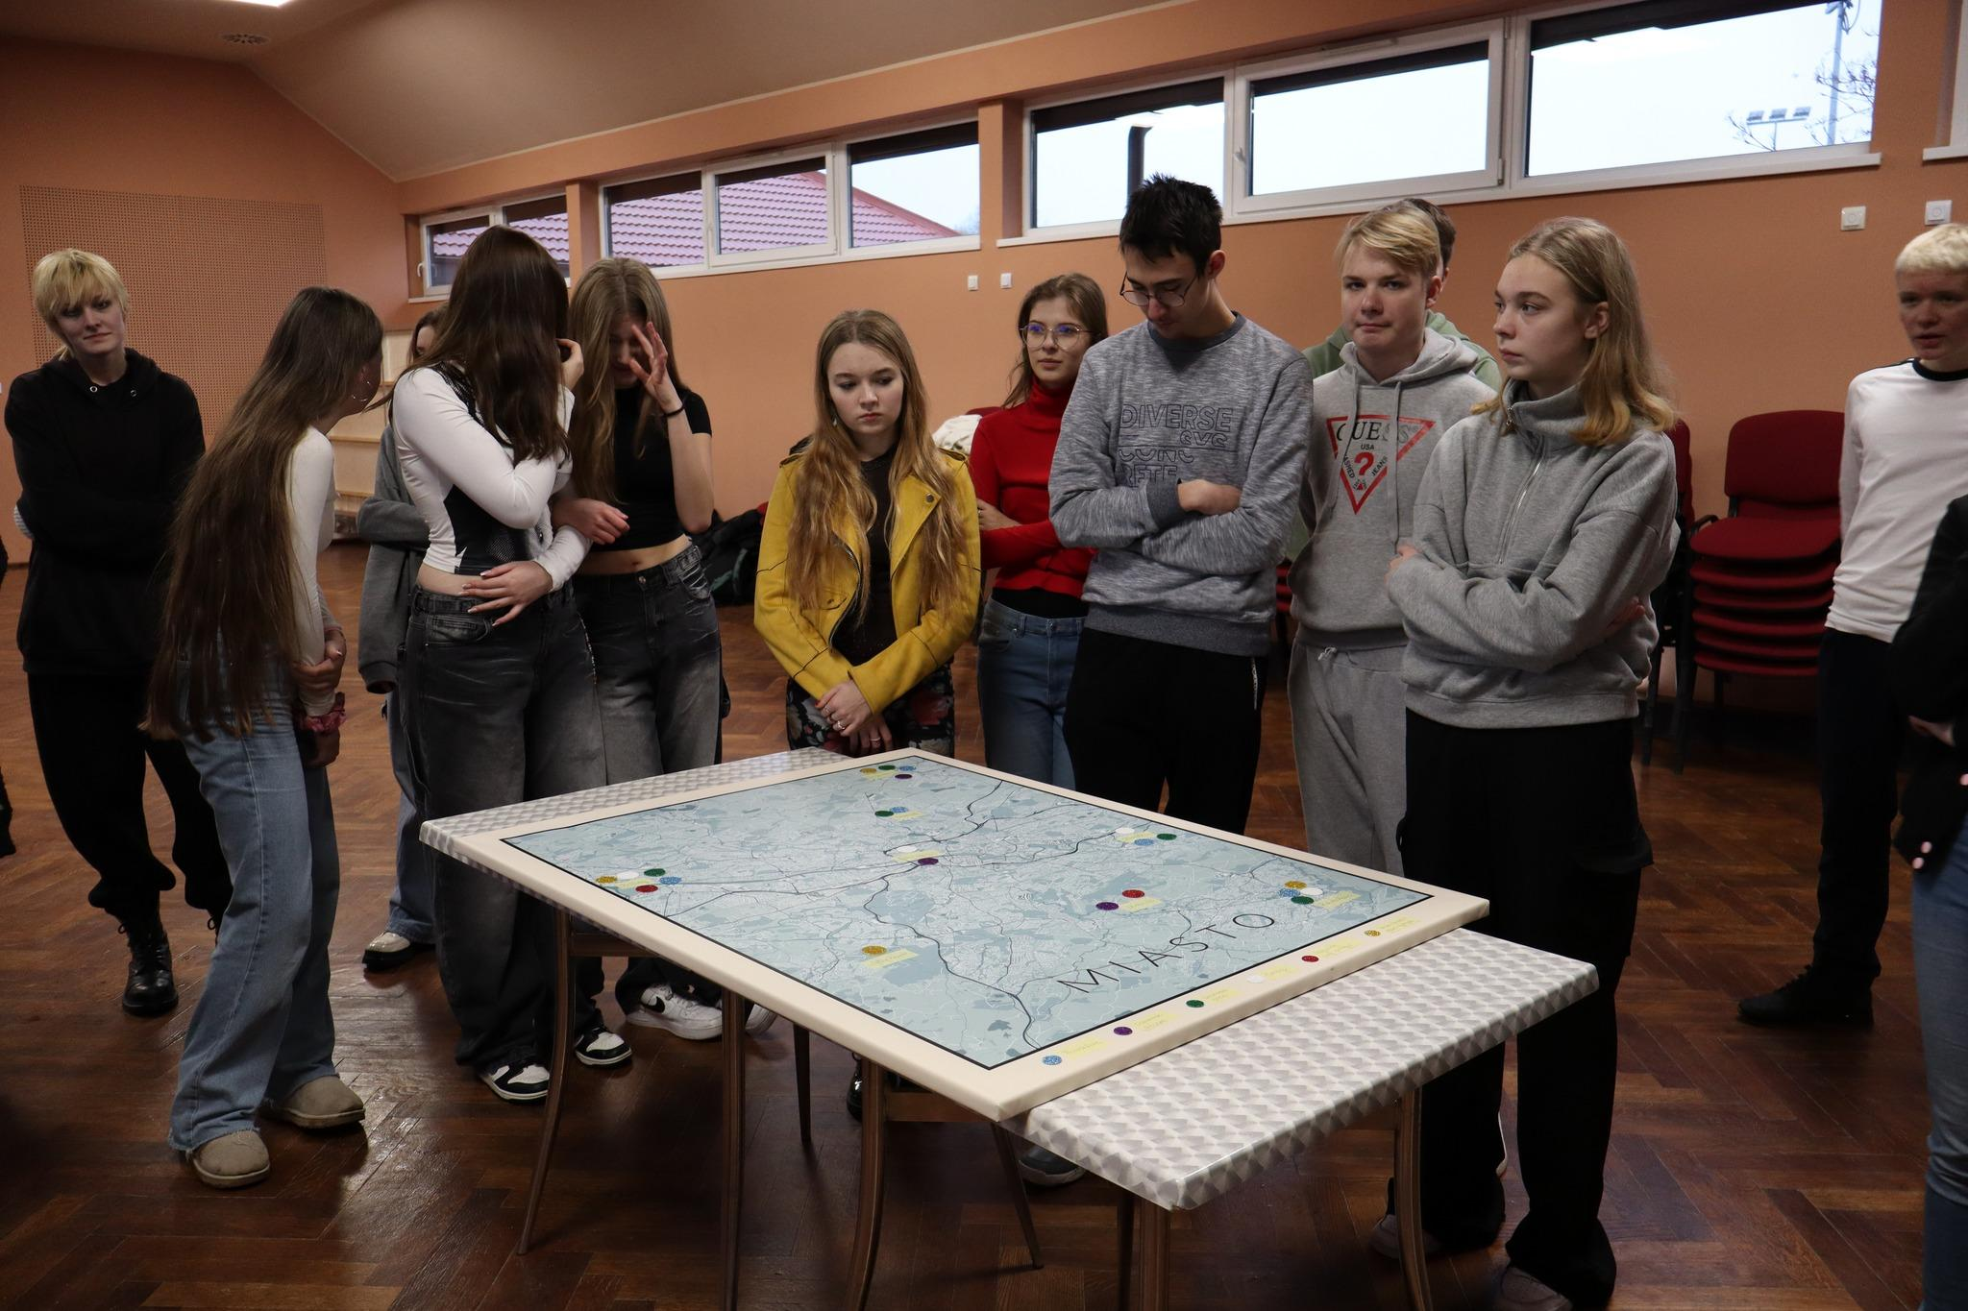

Circular Economy Game Design Methodology

LARPs
We specialize in LARP design and facilitation, treating it as a multisensory immersive experience allowing for active learning through the principles of pedagogy of experience, experiential learning cycle and situated learning.
Our games are not only designed as community-building tools but also as educational experiences which allow for the development of soft skills, as well as foster the raise of awareness about social and environmental issues. We combine emergent and environmental storytelling, roles and character embodiment with meaningful play and causality tied to consequences for the players to provide a meaningful learning environment.
Circular economy themes are present in our games not only via the topics and themes but also via the way we approach to the production process and sourcing of raw materials, props, scenography elements and costumes, which often come from donations,

Material Choices
Our games are written and stored on cloud-based servers, which allows for minimization of waste as well as swift and seamless distribution of materials to players (character sheets mainly). Promotion is also conducted online through social media platforms and is combined with information dissemination.
While designing scenography we tend to tend towards using second-hand materials, repurposing already-existing items, upcycling and recycling elements as well as borrowing them should they be for a limited use only. Much of our costume base consists of self-crafted costumes, second-hand bought garments and donated pieces. Production of both is considered only should it be necessary for fulfilling the artistic or educational vision of the particular project.
Packaging
Our LARPs do not require specific packaging. Scenography elements and props are delivered on site to transform designated space into the diegetic world of the game. Players may either prepare their costumes themselves or use our stockpile. In the case of educational LARPs, both scenography and costume use is limited to the necessary minimum due to the time constraints and the specific nature of participants, usually not accustomed to the offered experience.

Production methods and their environmental impact
We emphasize designing for specific circumstances, depending on the application of the game. Should it be an educational project design for the classroom setting, it is usually minimalistic in prop, scenography and costume use, taking into account the time and space constraints as well as the target group. Alternatively, if it is a more elaborate game, then we design with a specific location in mind, taking into consideration the necessary means to transform it into the desirable state.
We produce our written materials in online format to both distribute them to players and - in case of smaller scenarios - members of other LARP scenes as well as for the sake of easier storage, dissemination and reusability.

Incorporate Circular Economic Topics into Gameplay
When we tackle circular economy as a theme within our games, we conduct an in-depth research on specific aspects of the issue corresponding to the overall design and topic. Complex concepts and dependencies are broken into plot points and mechanics which illustrate them on the experiential level. The following are our most notable practices in that regard.
- Create roles depicting characters supporting circular economy introduction and its benefits.
- Craft resource-base mechanics which encourage long-term solutions and promote circular economy as a long-term strategy for solving issues on different organizational levels.
- Simulate real-world circular economy through mechanics and plot points with relevance to real-life situations.
- Imparting key facts and knowledge on the topic of circular economy onto the players trough character sheets, plot points and devices as well as props another diegetic elements.

Educational Aspects About Circular Economy
We use real-life examples and data acquired through extensive research tailored in accordance with the specific topics and issue particular game is to tackle. We always pre-face our games with an introduction on the topic giving our players both, the general content of the game itself as well as individual context for their character. The experience is followed by an educational debrief session which aims to sum up and structurize the knowledge gained by the players through the experience.

Player Engagement with Circular Economy Themes
Using LARPs as experiential learning modules, we tend to include discussed issues seamlessly on various levels of design so there is both causality and actionability for the players to partake in the games themselves. The following are our most common strategies to achieve this.
- Design a captivating yet not complex overall plot giving players the reasoning behind their characters motivations as well as room to make meaningful choices throughout the game.
- Create comprehensive characters with their own motivations and goals within the diegetic world.
- Design simple and engaging mechanics intertwined within the storytelling layer of the experience, which allow the players to actively solve in-game issues and have actionability over the overall outcome of the game.
- Adapt the topics discussed to the target audience so as to make presented issues relatable to the players.
- Provide players with props and costumes (if applicable) to further enhance the diegesis.
- Encourage players to think critically and apply circular economy principles beyond the game.
Lifecycle Analysis
Our games are produced in print & play format which means that - once published - the script can be reused multiple times by us or the client should they wish. We tend to reiterate and update said scripts based on research through design methodology until we accomplish the desired educational effects.
Instructions on how to run the games are an integral part of every print & play document we deliver, They detail not only how the game itself should be run but also what material components - outside of the ones provided - could enhance the experience. We usually try to limit prop and scenography use when it comes to in-school games.
We do not have specific method on measuring the carbon footprint and assessment of circular economy on our production, however we follow a simple principle of re-using and upcycling ready-made elements and materials

Conclusions and Recommendations

Fundacja Fantazmat has demonstrated not only how to introduce circular economy awareness into the design and themes concerning our games. We have also actively incorporated circular economy practices into our day-to-day operations, repurposing, recycling and upcycling items which may serve as elements of the LARP diegesis be it props, costumes or scenography parts. This not only reduces costs but also actively encourages non-linear economy models through a working example.
Throughout the process we came up with several principles in LARP design and facilitation in regard to circular economy principles, which could potentially be applied by other organizations wishing to follow a similar pattern.
- While designing the diegesis (costumes, props, scenography) prioritize materials that can be repurposed, recycled or upcycled.
- Provide games in print & play format for longevity and reusability, while also providing instructions on how to prepare the venue, what props and costumes to use etc.
- Integrate circular economy themes into gameplay and provide the games with educational debriefs summarizing the knowledge gained by players.
Circular Economy Games Examples
Role play about the circular economy: The case of waste management
Webpage/source: | https://www.connective-cities.net/en/media-centre/publications/publications-details/role-play-about-the-circular-economy-the-case-of-waste-management
Company or organization that has developed the game | United Cities And Local Governments
Type of game | edu-LARP
Description | This role game is based on the example of municipal waste management and provides a simple but realistic insight in the challenges of integrated management at the local level. The aim is to show that sustainable solutions for the municipality require the involvement and the commitment of different local actors.  Inspired by the efforts of UCLG members, the game presents the circular economy as a practice that promotes local and sustainable development while optimizing the use of resources. This effort can be directly linked to the Sustainable Development Goal 12: responsible production and consumption.
Circular Economy Features Checklist | The theme of the game is about waste management on the municipal level and how it can be subscribed to the circular economy trends.  Characters represent different local actors' involved in the process.
Images | 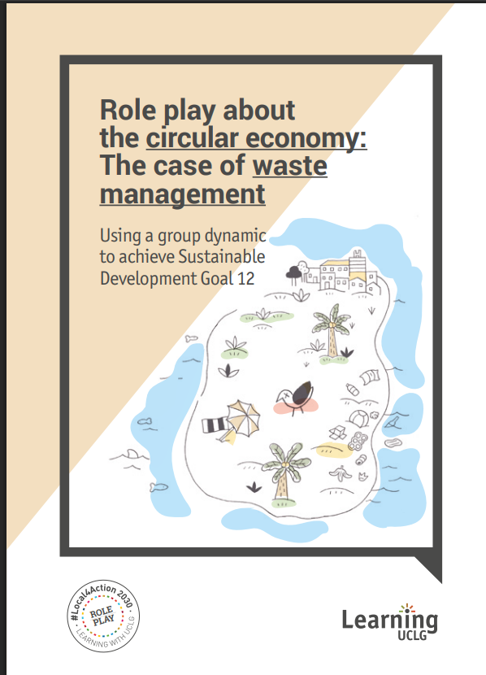

Sampah
Webpage/source: | https://www.facebook.com/fundacja.fantazmat
Company or organization that has developed the game | Funacja Fantazmat
Type of game | LARP
Description | In this game we explore the culture and customs of the Sampah tribe. This being a fictional species which constructs their lives and identities from waste coming to their level from “The Above”
Circular Economy Features Checklist | Mundane waste objects used as in-game props and costumes’ elements defining the characters.  Circular economy theme is touched upon through a mechanic of sharing and re-birthing through accepting trash items from other characters and incorporating them into one's identity.
Images | 